

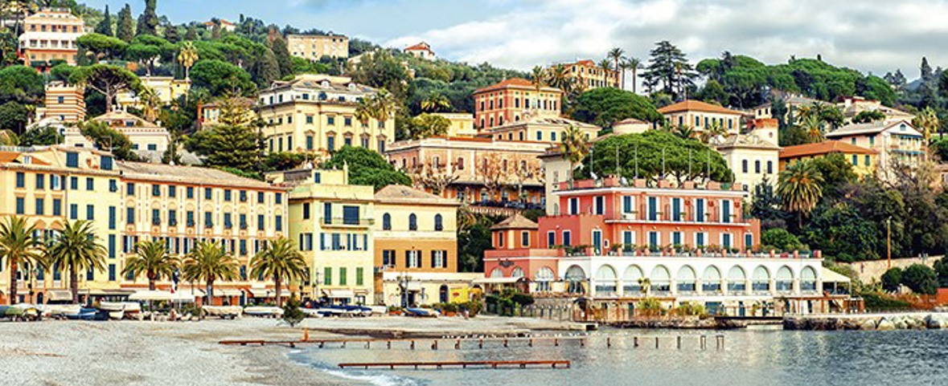Registration Form
Surname: ………………………………………………………….. Name: ………………………………………………………
Affiliation: ………………………………………………………………………………………………………………………………….
Date of birth: …………………………………Place of birth: ……………………………………………………………………
Private Address: …………………………………………………………………………………………………………………………
……………………………………………………………….…………………………………………………………………………………..
Email (#): ……………………………………………………………….. Telephone number (#): …………………………….
Fiscal code/VAT number: ………………………………………….
Accommodation:

- Single room 󠅿

- Double room
Roommate:.…………………………….….….…...

Arrival date: ……………………………………………. Departure date:……………………………………
Notes (food restrictions, allergies, and special needs): ……………………………………………………………………………………………………………………………………………………
…………………………………………………………………………………………………………………………………………………….

(#) Mandatory for COVID traceability

Participation fees
 | Scool members* (No VAT) |  | Non Scool members (VAT included)
 | Early | Regular | Early | Regular
Double room | 400 € | 450 € | 488 € | 549 €
Single room | 600 € | 650 € | 732 € | 793 €

* School participants can require the association to Scool upon workshop registration (see association request below).

Together with the registration to the Doctoral School, I also ASK to join the Association “Associazione Science is Cool” (SCOOL) as an ordinary associate, and to take advantages of the VAT reduction and all the related benefits.

To complete the membership process, I will pay an association fee of 2€ either on site or on line.

⧠ Yes, I want to join the Association “Associazione Science is Cool”
⧠ No, I don’t want to join the Association “Associazione Science is Cool”, fully aware that this prevents the access to the VAT free registration fee applicable to my case,

COVID-19 control and prevention
COVID-19 control and prevention rules are constantly updated according to the evolving situation.
The Organizing Committee follows the indications issued by the Italian Ministero della Salute as to the conference organization, and reserves the right to upgrade the requirement below, should the need arise, also by re-contacting previously registered participants.
☐ Upon arrival to the conference venue, I commit myself to providing upon request one of the following documents:
- a valid full vaccination certificate.
- a COVID recovery certificate issued less than six months before the start of the conference.
- a negative 72-hour PCR test or 48-hour rapid antigen test.
Please note that if those time spans are exceeded, the certificate/test is considered invalid and a new one must be provided.

___________________________________________________________________________________________________________

To comply with the new General Data Protection Regulation (GDPR) we need to ask for your explicit consent to communicate with you and process your data to make all necessary arrangements with you
regarding your attendance at or participation in the event. This includes but is not limited to sending you event-specific information, providing tickets or badges, raising invoices and arranging payment of fees, organising special / dietary requirements, secure access to the venue(s), published delegate/dinner lists and sending you post-event materials.

Please indicate if you wish to have your name and company name included on the event delegate list for other attendees.
⧠ Yes
⧠ No

Place/Date______________________________________ Signature_______________________________________________

------------------------------------------------------------------------------------------------------------------------------------------------------------------------------


SCOOL’s Goals

1. In the conviction that scientific culture is a fundamental contributor to economic development and cultural civil growth in our society, the Association has the objective to carry out cultural, educational and formative activities, in favour of associates and thirds, without a lucre purpose and in full respect of the associate’s freedom and dignity.
2. The Association’s purpose is not lucre, nor directly nor indirectly. Profits will be used exclusively for the realization of institutional activities and those strictly connected to them. Proceeds of the activities cannot, under no circumstance, be shared amongst associates, even by indirect procedures, other than when the destination or the distribution were imposed by law.
3.The Association is non-partisan and is without trade union character.

SCOOL’s Activities
The Association carries out the following activities:
a. It promotes scientific culture in all its aspects;
b. It establishes interactions with scholastic institutions of every level to spread scientific culture and technology amongst young people and, at the same time, strengthen teacher’s competence;
c. Develop and organize (in schools or in other seats) specific manual, artistic, expressive recreational activities finalized to point out the correlation between scientific culture and the other cultural spheres and to encourage curiosity towards nature and the universe, spirit of initiative, young people’s desire of knowledge;
d. It spreads an environmentally-friendly culture, proposing both intellectual and manual research activity on raw materials and recycling;
e. It publishes popular and scientific-cultural works and articles, through a website and other means of communication according to which is more appropriate;
f. It organizes national and international scientific workshops and conferences.

